امارت اسلامی افغانستان
وزارت تحصیلات عالی
ریاست موسسات خصوصی تحصیلات عالی
پوهنتون رڼا
ریاست پوهنحی کمپیوتر ساینس
آمریت دیپارتمنت انجنیری نرم افزار

Islamic Emirate of Afghanistan
Ministry of Higher Education
Directorate of Private Higher Education
RANA University
Directorate of Computer Science Faculty
Department of Software Engineering

MONOGRAPH PROPOSAL
ON

AutoCare Pro (Auto Repair Management System)
سیستم مدیریت ترمیم وسایل نقلیه

BY
Seyar
22-RE200-181
In partial fulfillment of the requirements for the award of the degree of
BACHELOR OF SOFTWARE ENGINEERING
BSE
TO
RANA University
Baraki Square, Kabul–Afghanistan

Islamic Emirate of Afghanistan
Ministry of Higher Education
Directorate of Private Higher Education
RANA University
Directorate of Computer Science Faculty
Department of Software Engineering

د افغانستان اسلامی امارت
د لوړو زده کړو وزارت
د لوړو زده کړو د خصوصي پوهنتونو ریاست
رڼا پوهنتون
د کمپیوټر ساینس پوهنځي ریاست
د سافت ویرانجنیرنګ ډیپارتمینت

MONOGRAPH PROPOSAL
ON
AutoCare Pro (Auto Repair Management System)
In partial fulfillment of the requirements for the award of the degree of
)BSE(
TO
RANA University
SUPERVISED BY:
Name:
Designation:
Qualification:
ID No:
Phone No:
E-mail:
TO BE PREPARED BY:
Name: Seyar
Father’s Name: Mohammad Alim
Registration No: 22-RE200-181
Phone No: +93781495456
E-Mail: seyarhakimi71@gmail.com
Batch: 2022 to 2026
Signature:
Date:
Signature:
Date:
Table of Contents

Introduction… 1
Existing System… 2
Proposed System… 2
Logical Design… 3
Physical Design… 5
Tools & Technologies… 6
Project Time & Cost Estimation… 7
Project Timeline… 8
PROJECT PROPOSAL APPROVAL SHEET… 10

1. Introduction
AutoCare Pro is a web-based management system for car wash and auto repair businesses. The system supports daily service operations from customer registration and vehicle intake to appointment scheduling, bay assignment, repair job cards, invoicing, payment tracking, and management reporting.
The project converts manual workshop and car wash processes into a centralized digital workflow. It gives owners, managers, reception staff, technicians, and cashiers a shared platform for tracking vehicles, services, parts, labor, payments, and operational performance.

Problem Statement and Background
Many car wash and auto repair shops still depend on paper job cards, verbal task assignment, notebooks, and disconnected spreadsheets. This causes missed appointments, unclear vehicle status, weak inventory control, delayed billing, and limited visibility into staff productivity and revenue.
The background of this project is the need for a simple, maintainable, and production-ready management system that fits small and medium automotive service businesses without adding unnecessary complexity.

Project Objectives
Provide secure role-based access for administrators, managers, receptionists, technicians, and cashiers.
Manage customers, vehicles, service packages, repair jobs, appointments, and service queues.
Track wash orders, repair job cards, assigned employees, parts usage, service status, invoices, and payments.
Maintain inventory records for spare parts, consumables, and low-stock alerts.
Generate operational reports for revenue, services, staff performance, appointments, and inventory movement.

Scope Summary
The scope covers the full workflow from customer and vehicle registration to appointment booking, check-in, service assignment, repair diagnosis, parts usage, billing, payment, and reporting. The system includes core business management features and avoids unrelated modules such as fleet GPS tracking, e-commerce marketplace functions, IoT hardware control, payroll processing, and complex accounting ledgers.

2. Existing System
The existing process in many car wash and repair shops is mostly manual. Customer details, vehicle information, requested services, repair notes, and payments are often recorded on paper or in basic spreadsheets. Staff members usually communicate service status verbally, which makes it difficult to know which vehicles are waiting, in service, completed, or unpaid.
This traditional workflow has several limitations. It increases the chance of lost records, duplicate customer entries, billing mistakes, uncontrolled parts usage, and weak reporting. Managers cannot easily measure daily revenue, service demand, technician workload, or inventory consumption.
Manual customer, vehicle, appointment, and job-card records.
No centralized queue for wash bays, repair bays, or technician assignment.
Weak tracking of spare parts, consumables, stock levels, and usage history.
Delayed invoice preparation and limited payment status visibility.
Limited reports for revenue, service trends, staff productivity, and inventory control.

3. Proposed System
The proposed system, AutoCare Pro, is a full-stack web application built with Next.js, React, TypeScript, Tailwind CSS, Node.js API routes, MongoDB, Mongoose, Clerk authentication, Stripe payments, Cloudinary file storage, Zod validation, and Vercel deployment. The system manages car wash services and auto repair operations through one secure dashboard.

Proposed Solution and Scope of Work
The solution will provide a complete automotive service workflow. Staff can register customers and vehicles, create appointments, check vehicles into the queue, select wash packages or repair services, assign technicians, record diagnosis notes, add parts and labor, generate invoices, accept payments, and close completed jobs. Managers can configure services, monitor inventory, and view reports.
Authentication, role-based dashboard access, and protected business routes.
Customer, vehicle, service package, appointment, queue, and job-card management.
Repair diagnosis, labor assignment, parts usage, service status, and completion tracking.
Inventory management for spare parts, chemicals, accessories, suppliers, and low-stock alerts.
Invoice generation, payment tracking, receipts, discounts, and daily cash summaries.
Reports for revenue, appointments, completed services, technician workload, and inventory movement.

Features to Avoid and Trust Signals
The system will avoid non-essential modules that increase cost and complexity, including GPS fleet tracking, IoT bay sensors, advanced payroll, full double-entry accounting, online marketplace sales, AI diagnosis, mobile native apps, and customer social features. These exclusions keep the project focused on the operational needs of a car wash and repair business.
Trust signals include typed implementation with TypeScript, schema validation with Zod, authenticated server actions, indexed MongoDB collections, role-based access rules, structured diagrams, and validation through linting, production build, and core workflow testing.

4. Logical Design
The logical design describes how customers, staff, external services, processes, and data stores interact in the system. The DFD diagrams show the main flow from appointment booking and vehicle intake to service execution, inventory usage, invoicing, payment, and reporting. The logical ERD shows the main entities and their relationships in Chen style.
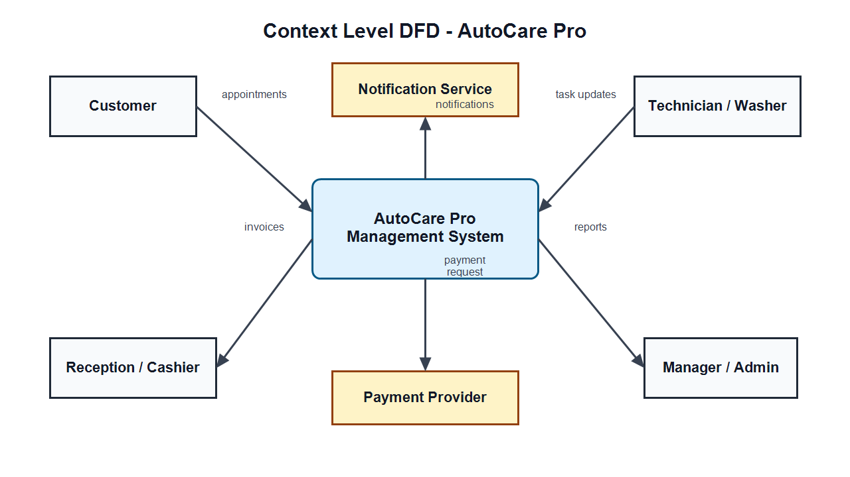
Figure 1 shows the context-level DFD between customers, staff, management, the AutoCare Pro system, the payment provider, and notification service.
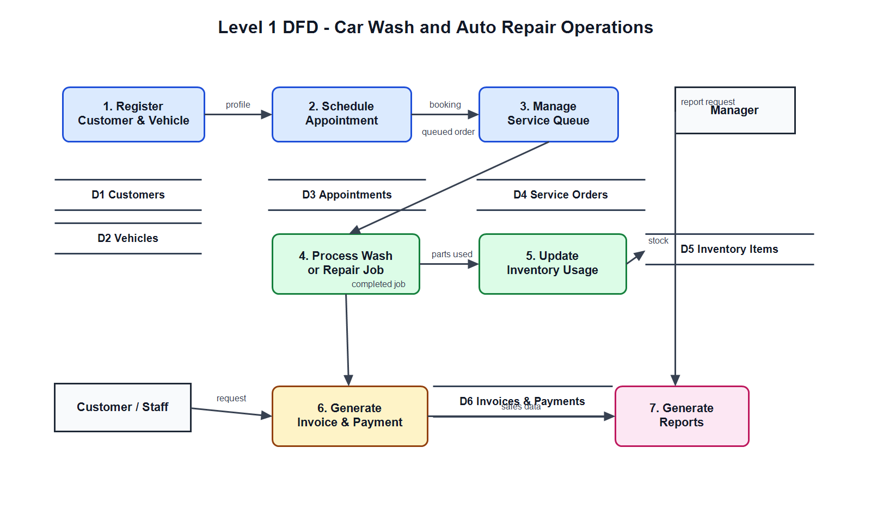
Figure 2 shows the level-1 DFD for customer registration, appointment handling, queue management, service processing, inventory usage, billing, and reports.
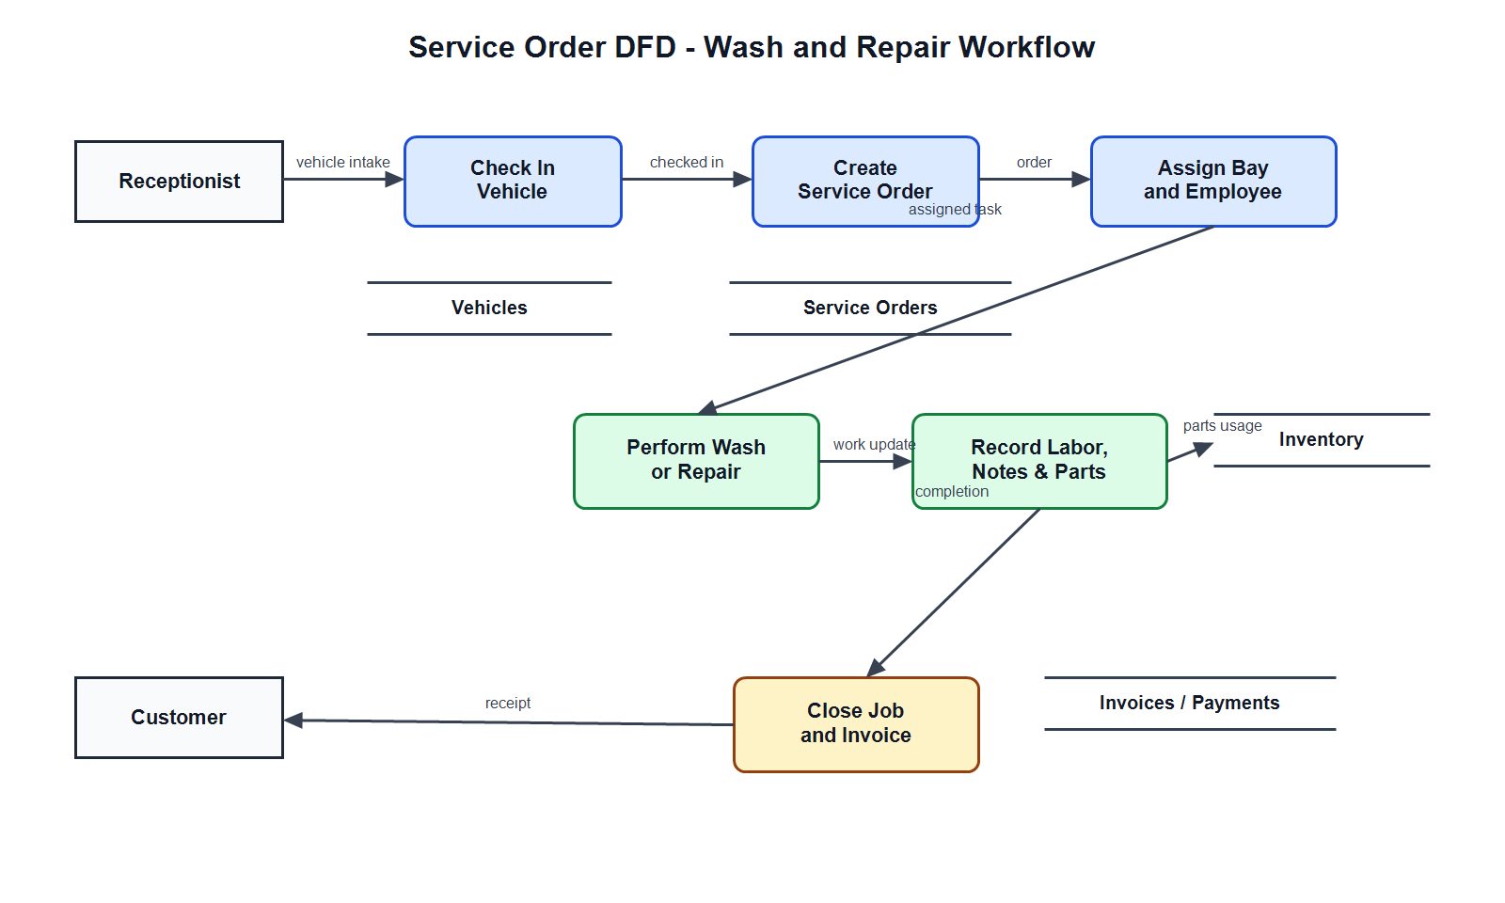
Figure 3 shows the service-order DFD for vehicle check-in, wash or repair task assignment, technician updates, parts usage, invoice generation, and payment confirmation.
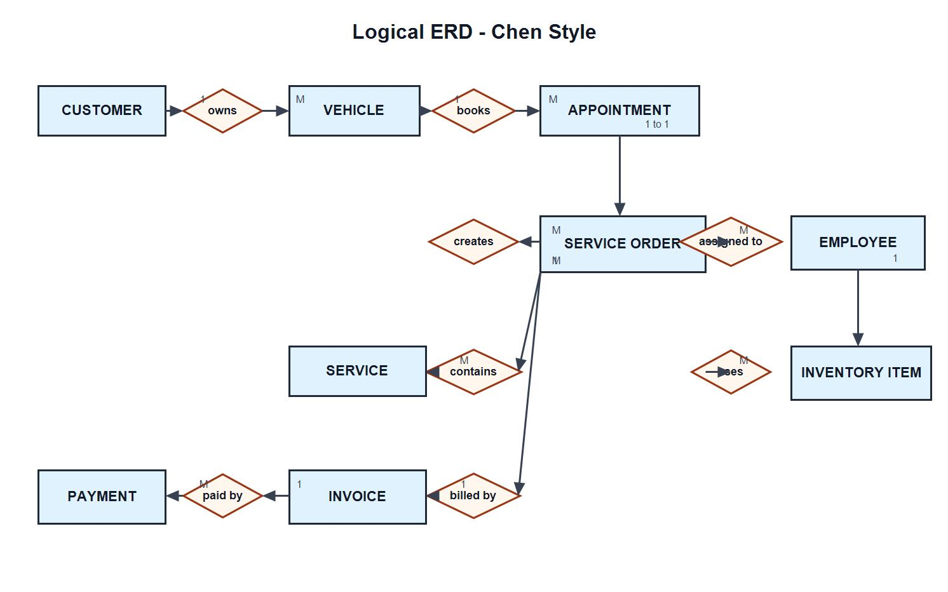
Figure 4 shows the logical Chen-style ERD for Customer, Vehicle, Appointment, ServiceOrder, Service, Employee, InventoryItem, Invoice, and Payment.

5. Physical Design
The physical design maps the logical system into implementation components. The frontend and backend are implemented with Next.js App Router and TypeScript. MongoDB stores customers, vehicles, appointments, service orders, services, employees, inventory items, invoices, and payments. Clerk manages authentication and role-based access. Stripe handles online payment records where required. Cloudinary stores vehicle photos, inspection images, and receipt attachments.
The physical database design contains collections with required fields, optional fields, timestamps, references, and indexes. Search indexes are used for customer phone numbers, vehicle plate numbers, appointment dates, service-order status, invoice numbers, and inventory SKU values.
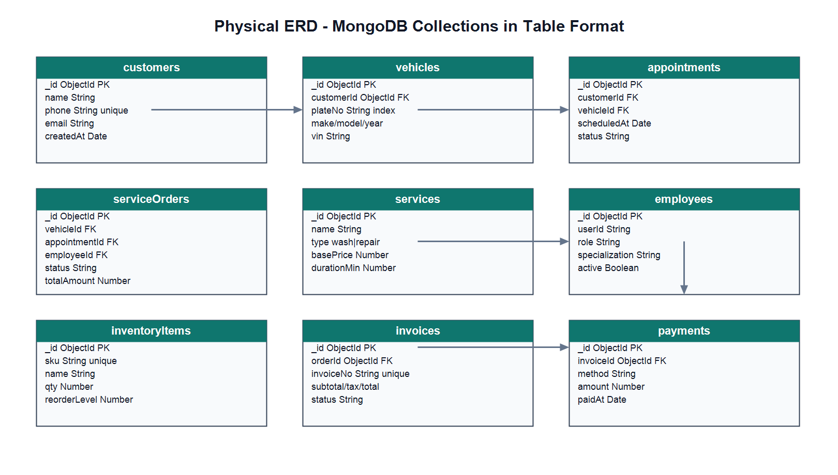
Figure 5 shows the physical MongoDB ERD in table format, including fields, types, keys, references, indexes, and constraints.

6. Tools and Technologies
Tool or Technology | Purpose | Justification
Next.js App Router | Routing, API routes, server actions, and deployment structure | Provides a modern full-stack framework for production web applications.
React | User interface components | Supports reusable dashboards, forms, tables, and interactive service workflows.
TypeScript | Typed application development | Reduces runtime errors and improves maintainability.
Tailwind CSS | Application styling | Enables consistent, responsive, and maintainable interface styling.
Clerk | Authentication and role-based access | Provides secure identity, sessions, and protected dashboard access.
MongoDB and Mongoose | Database and schema modeling | Stores operational records for customers, vehicles, jobs, inventory, invoices, and payments.
Stripe | Payment processing and payment records | Supports card payments and structured payment confirmation when online payment is enabled.
Cloudinary | Image and document storage | Stores vehicle photos, inspection images, receipts, and related attachments.
Zod | Input validation | Validates forms, API payloads, and business rules before persistence.
React Hook Form | Form state management | Handles complex service, appointment, invoice, and inventory forms efficiently.
Vercel | Hosting and deployment | Provides reliable deployment for the Next.js application.
ESLint and Prettier | Code quality and formatting | Keeps the codebase consistent and easier to maintain.

7. Project Time and Cost Estimation
The following estimate is prepared for an academic project context. Labor is calculated at a student project rate of USD 5 per hour. Cloud and API costs are estimated for development, testing, and demonstration usage.
Category | Estimated Hours | Rate or Basis | Estimated Cost
Requirements, proposal, and documentation | 35 | $5/hour | $175
UI design and frontend implementation | 60 | $5/hour | $300
Customer, vehicle, appointment, and queue modules | 45 | $5/hour | $225
Service orders, repair jobs, and technician workflow | 55 | $5/hour | $275
Inventory, invoice, payment, and report modules | 55 | $5/hour | $275
Authentication, roles, file uploads, and deployment | 35 | $5/hour | $175
Testing, validation, and final preparation | 25 | $5/hour | $125
Estimated labor subtotal | 310 | Academic estimate | $1,550
Cloud/API/testing allowance | - | Development and demo usage | $120
Contingency | - | Risk and service variation allowance | $160
Estimated total | - | USD | $1,830

8. Project Timeline
Period | Milestone | Main Activities | Deliverable
Week 1 | Requirements and proposal | Define problem, objectives, scope, features to include, and features to avoid. | Approved project proposal
Week 2 | UI/UX and logical design | Prepare dashboard flows, DFD diagrams, Chen ERD, and physical database design. | Design and diagrams
Weeks 3-4 | Customers, vehicles, appointments, and queue | Implement customer profiles, vehicle records, appointment scheduling, and service queue. | Working intake module
Week 5 | Service orders and repair workflow | Implement wash orders, repair job cards, technician assignment, diagnosis, and task updates. | Service workflow module
Weeks 6-7 | Inventory, invoices, and payments | Implement stock records, parts usage, invoices, receipts, payment tracking, and discounts. | Billing and inventory module
Week 8 | Reports and management dashboard | Implement revenue, appointment, service, staff, and inventory reports. | Reporting module
Week 9 | Testing and deployment | Run lint, build, workflow testing, role checks, and deployment preparation. | Test evidence and deployed demo
Week 10 | Final review and submission | Review diagrams, proposal, demo script, and final presentation materials. | Final monograph submission

PROJECT PROPOSAL APPROVAL SHEET

The undersigned certify that they have read the following Project Proposal and are satisfied with the overall contents and idea, and recommend the project proposal to the faculty of Computer Science for acceptance.

Title: AutoCare Pro (Auto Repair Management System)
Prepared by: Seyar

Recommended by: Mr. Sayed Hassan Sabit
Vice Dean & Coordinator

Project Coordinator: Mr. Sayed Hassan Sabit

Dean of BCS Faculty: Mr. Abdul Ghafar Omarkhel

